A 1969 batch alumnus returns to PEC to deliver lecture on RF spectrum allocation

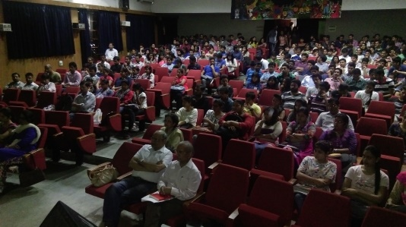 | 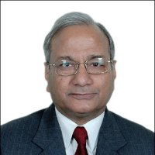 | 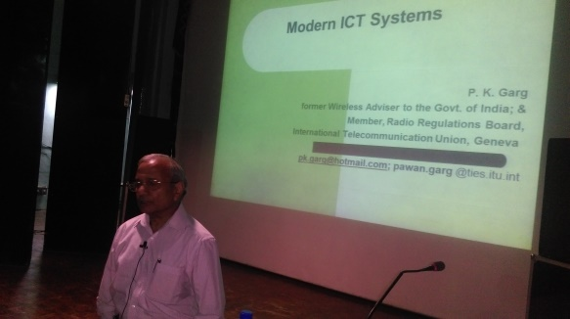

The department of Electronics and Communication Engineering of PEC University of Technology, Chandigarh organized an expert lecture on “Developments in wireless communication technologies and their impact on mankind” on 15th October 2015 in the Institute Auditorium which was attended by more than 300 enthusiastic UG, PG, Ph.D. students and Faculty members from various departments. The lecture was delivered by Sh. P. K. Garg, PEC alumnus (Electronics and Electrical Communication Engg) 1969 Batch. He has been the former Wireless Adviser to the Govt. of India and currently serving as the Member, Radio Regulations Board, International Telecommunication Union, Geneva, which issues advisories/guidelines to distribute RF spectrum worldwide. Dr. Neena Gupta, Professor & Head, ECE Department PEC University of Technology, Chandigarh, introduced the illustrious career of Sh. P. K. Garg.

Mr. Garg discussed about the Major Developments during last 25 Years in IT and Telecom sector. He emphasized on RF Spectrum as a crucial resource for modern ICTs. He further demonstrated the basics of RF spectrum and need for regulation of the spectrum. Thereafter, he elaborated about the Radio Regulations which are an international treaty among countries regarding the use of Radio Frequency (RF) Spectrum. These Regulations are evolved & periodically revised at World Radio-communication Conferences. He also discussed about the major developments in telecom and communication system; he also talked over about the establishment of the International Telecommunication Union (ITU).

The lecture was highly enlightening particularly for the younger generation of engineers /researchers to understand the technological innovations taking place in the field, around the world.

Thanks and Regards
Sovina Sood
PRO
PEC University of tech

